**Music Store Sql QUERIES**

**A. Easy Set**

**Q1. Who is the senior most employee based on job title?**

select * from employee

order by levels desc

limit 1;

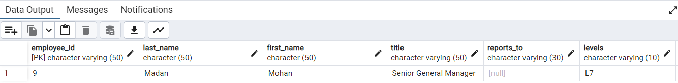

**Q2: Which city have the most Invoices?**

select * from invoice;

select billing_city ,count(*) as invoices

from invoice

group by billing_city

order by invoices desc

limit 1;

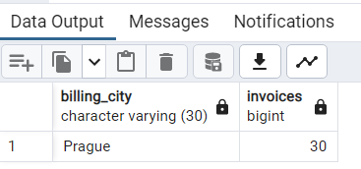

**Q3: What are top 3 values of total invoice?**

select * from invoice;

select total from invoice

order by total desc

limit 3

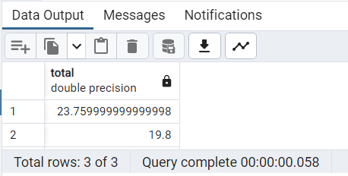

**Q4: Which city has the best customers? We would like to throw a promotional Music Festival in the city we made the most money.**

**Write a query that returns one city that has the highest sum of invoice totals.**

**Return both the city name & sum of all invoice totals**

select billing_city,sum(total) as Highest_Invoice

from invoice

group by billing_city

order by Highest_Invoice desc

limit 1

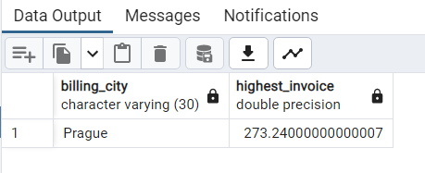

**Q5: Who is the best customer? The customer who has spent the most money will be declared the best customer.**

**Write a query that returns the person who has spent the most money.**

select * from customer;

select c.customer_id,c.First_name,c.last_name,country,sum(i.total) as Total_Spending

from Customer as c

Inner Join Invoice as i

on c.customer_id=i.customer_id

group by c.customer_id,c.first_name,c.country

order by Total_Spending desc

limit 1;

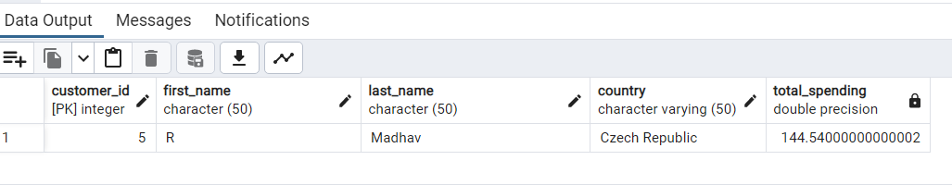

**B. Moderate Set  
Q1: Write query to return the email, first name, last name, & Genre of all Rock Music listeners.**

**Return your list ordered alphabetically by email starting with A.**

select distinct c.email,c.first_name,c.last_name,g.name

from customer as c

inner join invoice as i

on c.customer_id=i.customer_id

inner join invoice_line as il

on i.invoice_id=il.invoice_id

inner join track

on il.track_id=track.track_id

inner join genre as g

on track.genre_id=g.genre_id

where g.name='Rock'

order by c.email asc;

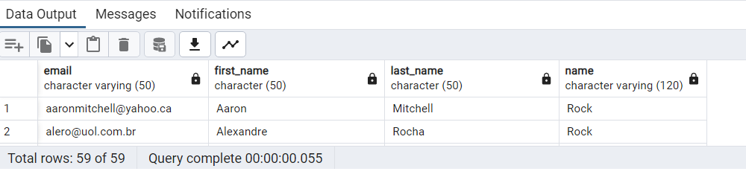

**Q2: Let's invite the artists who have written the most rock music in our dataset.**

**Write a query that returns the Artist name and total track count of the top 10 rock bands.**

select artist.artist_id,artist.name,count(artist.artist_id) as total_track

from artist

inner join album

on artist.artist_id=album.artist_id

inner join track

on album.album_id=track.album_id

inner join genre

on track.genre_id=genre.genre_id

where genre.name='Rock'

Group by artist.artist_id

order by total_track desc

limit 10;

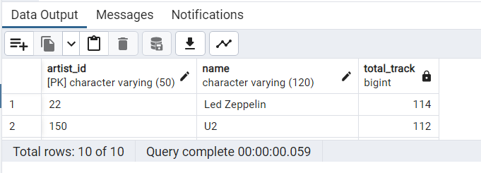

**Q3: Return all the track names that have a song length longer than the average song length.**

**Return the Name and Milliseconds for each track. Order by the song length with the longest songs listed first.**

**select name,milliseconds from track where milliseconds >**

**(select AVG(Milliseconds) from track)**

**order by milliseconds desc ;**

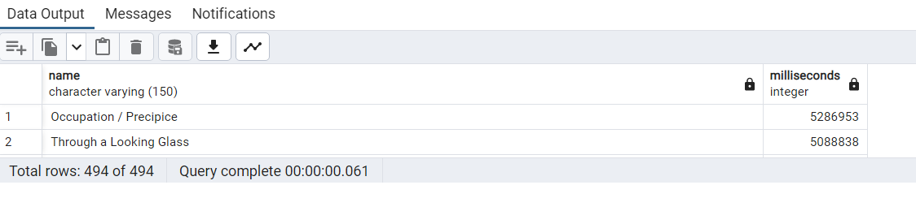

**C. Advance Set**

**Q1. Find how much amount spent by each customer on artists who have earned the most? Write a query to return customer name, artist name and total spent**

**\*/ Method 1*/**

with cte as(

select a.artist_id,a.name,sum(il.unit_price *il.quantity) as total_spent

from artist as a

inner join album as al

on a.artist_id=al.artist_id

inner join track as t

on al.album_id=t.album_id

inner join invoice_line as il

on t.track_id=il.track_id

group by a.artist_id

order by total_spent desc

limit 1

)

select c.customer_id,c.first_name,c.last_name,cte.name,sum(il.unit_price *il.quantity) as total_spent

from customer as c

inner join invoice as i

on c.customer_id=i.customer_id

inner join invoice_line as il

on i.invoice_id=il.invoice_id

inner join track as t

on il.track_id=t.track_id

inner join album as al

on t.album_id=al.album_id

inner join cte

on cte.artist_id=al.artist_id

group by 1,2,3,4

order by total_spent desc;

**/* Method 2 */**

select c.customer_id,c.first_name,c.last_name,c.country,ar.name,

sum(il.quantity * il.unit_price)

from customer as c

inner join invoice as i

on c.customer_id=i.customer_id

inner join invoice_line as il

on i.invoice_id=il.invoice_id

inner join track as t

on il.track_id=t.track_id

inner join album as a

on a.album_id=t.album_id

inner join artist as ar

on ar.artist_id=a.artist_id

group by 1,2,3,4,5

having ar.name='Queen'

order by 6 desc

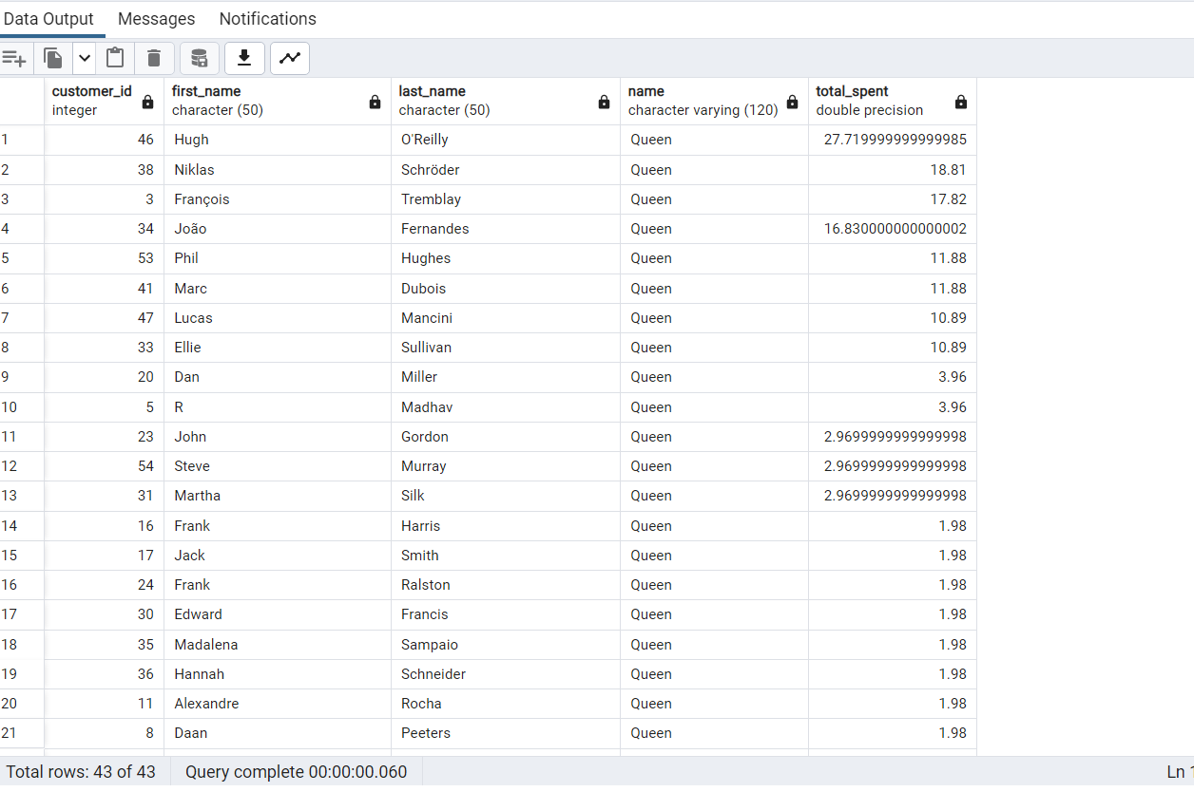

**Q2: We want to find out the most popular music Genre for each country. We determine the most popular genre as the genre**

**with the highest amount of purchases. Write a query that returns each country along with the top Genre. For countries where**

**the maximum number of purchases is shared return all Genres.**

with popular_genre as

select i.billing_country,g.name,sum(il.quantity) as total_purchase,sum(i.total) as total_spent,

row_number() over(Partition by billing_country order by sum(il.quantity) desc) as ranks

from invoice i

inner join invoice_line as il

on i.invoice_id=il.invoice_id

inner join track as t

on il.track_id=t.track_id

inner join genre as g

on t.genre_id=g.genre_id

group by 1,2

)

Select * from popular_genre where ranks =1;

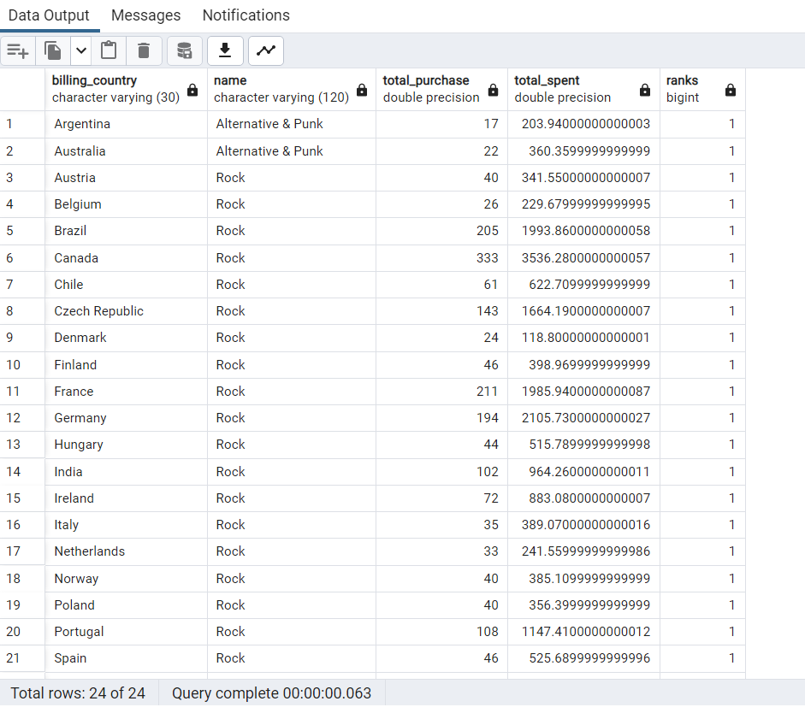

**Q3: Write a query that determines the customer that has spent the most on music for each country.**

**Write a query that returns the country along with the top customer and how much they spent.**

**For countries where the top amount spent is shared, provide all customers who spent this amount**

WITH Customter_with_country AS (

SELECT customer.customer_id,first_name,last_name,billing_country,SUM(total) AS total_spending,

ROW_NUMBER() OVER(PARTITION BY billing_country ORDER BY SUM(total) DESC) AS RowNo

FROM invoice

JOIN customer ON customer.customer_id = invoice.customer_id

GROUP BY 1,2,3,4

ORDER BY 4 ASC,5 DESC)

SELECT * FROM Customter_with_country WHERE RowNo <= 1

